**Comprehensive digital marketing for hatsun Argo products limited**

When developing a comprehensive digital marketing strategy for Hatsun Agro Product Limited, it's essential to consider the company's established presence and the evolving digital landscape. Here's a breakdown of key areas to focus on:

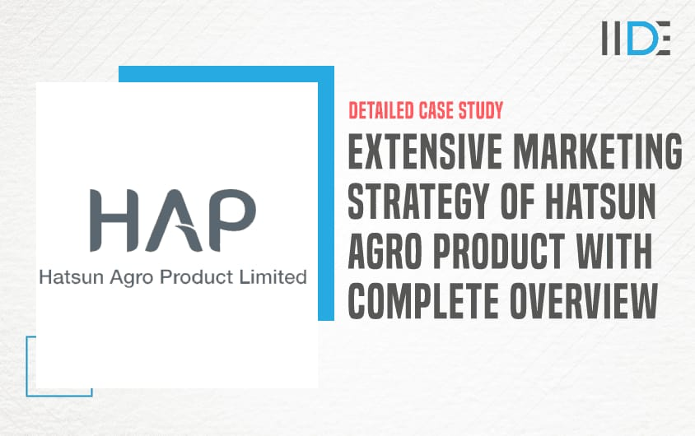

**1. Understanding Hatsun Agro's Digital Presence:**

* **Existing Strengths:**
  + Hatsun Agro has a strong foundation in traditional marketing and is building its digital presence.
  + They are actively utilizing social media platforms.
* **Areas for Improvement:**
  + Enhancing SEO strategies.
  + Leveraging data analytics for better targeting.
  + Expanding digital engagement and customer interaction.

**2. Key Digital Marketing Strategies:**

* **Search Engine Optimization (SEO):**
  + Conduct thorough keyword research to target relevant search terms.
  + Optimize website content for search engines.
  + Build high-quality backlinks to improve website authority.
  + Focus on local SEO to reach regional consumers.
* **Social Media Marketing:**
  + Develop engaging content that showcases Hatsun Agro's products and values.
  + Utilize various social media platforms (Facebook, Instagram, YouTube, etc.) to reach different target audiences.
  + Run targeted social media advertising campaigns.
  + Engage with followers and respond to comments and messages.
  + Utilize influencer marketing.
* **Content Marketing:**
  + Create valuable and informative content, such as blog posts, articles, and videos, related to dairy products, nutrition, and healthy living.
  + Share user-generated content to build community and trust.
  + Develop visually appealing content to showcase products.
* **Digital Advertising:**
  + Run targeted online advertising campaigns on platforms like Google Ads and social media.
  + Utilize retargeting to reach customers who have previously interacted with the brand.
  + Track campaign performance and optimize for maximum ROI.
* **E-commerce and Online Sales:**
  + Enhance online platforms for direct consumer sales.
  + Explore partnerships with online grocery delivery services.
  + Optimize the online customer experience.
* **Data Analytics:**
  + Utilize data analytics tools to track website traffic, social media engagement, and campaign performance.
  + Analyze data to identify trends and insights.
  + Use data to optimize marketing strategies and improve ROI.
* **Customer Relationship Management (CRM):**
  + implement crm strategies to maintain customer relationships.
  + Utilizing email marketing to keep customers informed.
  + Creating loyalty programs.

**3. Key Considerations:**

* **Target Audience:**
  + Identify and understand the target audience for each product.
  + Tailor marketing messages and content to resonate with specific audience segments.
* **Regional Focus:**
  + Recognize the importance of regional markets and tailor digital marketing efforts accordingly.
  + Utilize local language content and regional social media influencers.
* **Brand Consistency:**
  + Maintain a consistent brand message and visual identity across all digital channels.
* **Mobile Optimization:**
  + Ensure that all digital platforms and content are optimized for mobile devices.

**Brand study, competitor analysis &buyer's/audience's persona**

To effectively strategize for Hatsun Agro Products Limited, a deep dive into its brand, competitors, and target audience is crucial. Here's a breakdown of those key areas.

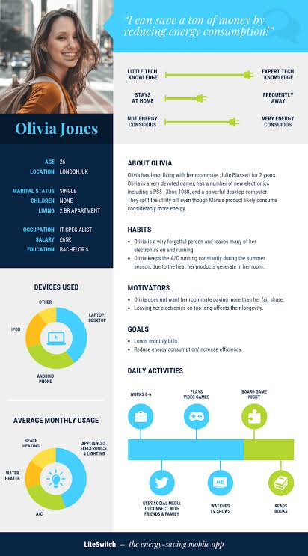

**1. Brand Study:**

* **Brand Identity and Values:**
  + Hatsun Agro has built a reputation for quality and reliability, particularly in Southern India.
  + Key values include:
    - Direct farmer sourcing and fair practices.
    - Quality and freshness of products.
    - Strong distribution network.
  + Brands like "Arokya" (milk) and "Arun Icecreams" have strong regional recognition.
* **Brand Strengths:**
  + Extensive and efficient milk procurement network.
  + Strong presence in Southern India.
  + Diverse product portfolio.
  + Established distribution channels.
* **Brand Considerations:**
  + Expanding brand recognition in other regions.
  + Adapting to evolving consumer preferences for healthy and convenient products.
  + Maintaining the quality of products, with growing production demands.

**2. Competitor Analysis:**

* **Key Competitors:**
  + Amul: A major national player with a wide range of dairy products.
  + Mother Dairy: Another significant competitor with a strong presence in various regions.
  + Local and regional dairy brands: Which vary from region to region.
* **Competitive Landscape:**
  + The dairy industry is highly competitive, with established national brands and numerous regional players.
  + Competition focuses on:
    - Price.
    - Product quality and variety.
    - Distribution network.
    - Brand recognition.
* **Competitive Advantages:**
  + Hatsun Agro's strength lies in its strong regional presence and efficient supply chain.
  + Differentiating factors could include:
    - Emphasis on direct farmer sourcing and quality.
    - Regional brand loyalty.
    - Adapting to local customer desires.

**3. Buyers/Audience Persona:**

* **Target Audience Segments:**
  + **Families:** Seeking fresh, nutritious dairy products for daily consumption.
  + **Health-conscious consumers:** Looking for products with specific nutritional benefits.
  + **Urban consumers:** Prioritizing convenience and accessibility.
  + **Rural consumers:** Reliant on accessible and affordable dairy products.
  + **Ice cream consumers:** Those seeking a variety of flavors and quality frozen desserts.
* **Audience Persona Characteristics:**
  + **Demographics:** Varying age groups, income levels, and geographic locations.
  + **Psychographics:** Values, lifestyles, and purchasing behaviors.
  + **Needs and Preferences:**
    - Freshness and quality.
    - Affordability.
    - Convenience.
    - Variety of product options.
    - Increasing intrest in products that are produced in a sustainable way.
* **Key Considerations:**
  + Understanding the regional variations in consumer preferences.
  + Adapting marketing messages to resonate with specific audience segments.
  + Utilizing digital platforms to reach younger, tech-savvy consumers.

**Research brand identity**

**Core Elements of Hatsun Agro's Brand Identity:**

* **Emphasis on Quality and Freshness:**
  + A core component of Hatsun's brand is its focus on delivering fresh, high-quality dairy products. This is heavily tied to their direct sourcing from farmers.
* **Strong Regional Presence:**
  + Hatsun has cultivated a very strong brand presence, particularly in Southern India. This regional dominance is a significant part of their identity.
* **Reliability and Trust:**
  + The brand has built a reputation for reliability, with consumers trusting the quality and consistency of their products.
* **Direct Farmer Sourcing:**
  + A key differentiator is their emphasis on direct relationships with farmers, which reinforces the brand's commitment to quality and ethical practices.
* **Diversified Brand Portfolio:**
  + Hatsun encompasses a range of well-known sub-brands, each with its own identity:
    - **Arokya:** Known for its fresh milk and curd.
    - **Arun Icecreams:** A popular ice cream brand with a wide variety of flavors.
    - **Hatsun (General):** Used for various dairy products like ghee and paneer.
    - **Ibaco:** Their premium ice cream brand.
* **"Goodness with care, from our villages"**
  + This phrase captures much of the companies ethos. It highlights the companies connection to rural farming communities, and the care taken in producing their products.

**Key Takeaways:**

* Hatsun Agro's brand identity is built on a foundation of quality, reliability, and strong regional connections.
* Their direct farmer sourcing practices contribute to a positive brand image.
* The diversified brand portfolio allows them to cater to a wide range of consumer preferences.

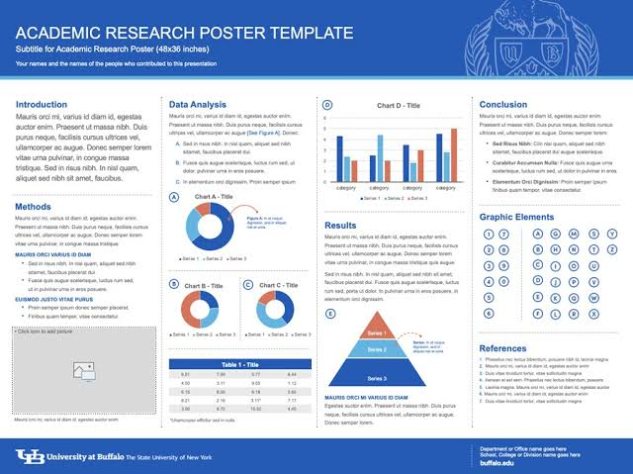

**Competitor Analysis**

Analyzing Hatsun Agro Products Limited's competitive landscape involves identifying key players and understanding their strengths and strategies. Here's a breakdown of the competitive environment:

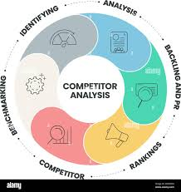

**Key Competitors:**

* **Amul:**
  + A dominant national player with a vast product portfolio and extensive distribution network.
  + Known for its strong brand recognition and competitive pricing.
* **Mother Dairy:**
  + A significant competitor with a strong presence in various regions, particularly in North India.
  + Offers a wide range of dairy products and has a strong focus on quality.
* **Regional Dairy Brands:**
  + Various local and regional dairy brands that compete with Hatsun Agro in specific geographic areas.
  + These brands often have strong local ties and understand regional consumer preferences.
* **Nestle India Ltd.:**
  + While having a very diverse portfolio, Nestle is a very large competitor in the food and beverage industry, and therefore competes with Hatsun Agro in many sectors.
* **Britannia Industries Ltd.:**
  + Like Nestle, Britannia is a large player in the food industry, and while not solely focused on dairy, they do compete in related product areas.

**Competitive Factors:**

* **Product Portfolio:**
  + Competitors offer a wide range of dairy products, including milk, curd, butter, cheese, and ice cream.
  + Product innovation and variety are key competitive factors.
* **Distribution Network:**
  + A strong distribution network is essential for reaching consumers, particularly in rural areas.
  + Competitors with extensive distribution networks have a significant advantage.
* **Pricing:**
  + Price competition is intense, particularly in the mass-market segment.
* **Brand Recognition:**
  + Strong brand recognition and consumer trust are crucial for building market share.
* **Quality and Freshness:**
  + Consumers increasingly prioritize quality and freshness, making these key competitive differentiators.
* **Supply Chain:**
  + Efficient supply chain management, from sourcing to distribution, is critical for maintaining product quality and controlling costs.

**Hatsun Agro's Competitive Strengths:**

* **Strong Regional Presence:** Hatsun Agro has a very strong foothold in southern india.
* **Efficient Milk Procurement:** Their direct sourcing from farmers ensures quality and efficient supply.
* **Diversified Product Range:** Hatsun Agro has a broad portfolio of products, including popular brands like Arokya and Arun Icecreams.

**Buyer's/audience’s persona**

When crafting a digital marketing strategy for Hatsun Agro Products Limited, it's crucial to define the target audience and create detailed buyer personas. Here's a breakdown of key audience segments and their characteristics:

**Key Audience Personas:**

* **The "Health-Conscious Household Manager":**
  + **Demographics:** Typically female, aged 25-45, living in urban or semi-urban areas.
  + **Psychographics:** Values healthy eating, prioritizes fresh and natural products, actively seeks nutritional information.
  + **Digital Behavior:** Regularly uses social media for recipe inspiration and product research, reads online reviews, shops for groceries online.
  + **Needs:** Seeks high-quality dairy products for her family, interested in products with low-fat or added nutritional benefits, values transparency in sourcing and production.
  + **Digital Engagement:** Responds to content that highlights the health benefits of dairy, engages with recipe videos and nutritional information, participates in online contests and promotions.
* **The "Convenience-Seeking Urban Professional":**
  + **Demographics:** Aged 22-35, living in urban areas, busy lifestyle.
  + **Psychographics:** Values convenience and efficiency, prefers online shopping and delivery services.
  + **Digital Behavior:** Heavily reliant on mobile devices, uses food delivery apps, follows brands on social media for updates and promotions.
  + **Needs:** Seeks readily available and easy-to-consume dairy products, values quick delivery and online ordering options.
  + **Digital Engagement:** Responds to targeted ads on social media, utilizes online ordering platforms, engages with short-form video content.
* **The "Traditional Family Shopper":**
  + **Demographics:** Aged 35-60, living in urban or rural areas, values tradition and family.
  + **Psychographics:** Prioritizes affordability and reliability, trusts established brands, shops at local stores.
  + **Digital Behavior:** Uses social media to stay connected with family and friends, may rely on word-of-mouth recommendations.
  + **Needs:** Seeks affordable and readily available dairy products for daily consumption, values consistent quality and taste.
  + **Digital Engagement:** Responds to regional language content, engages with community-focused social media posts.
* **The "Ice Cream Enthusiast":**
  + **Demographics:** Spans a wide age range, with a particular focus on younger consumers.
  + **Psychographics:** Seeks indulgence and enjoyment, values variety and flavor.
  + **Digital Behavior:** Actively engages with visually appealing content on social media, follows food and dessert trends.
  + **Needs:** Seeks a wide variety of ice cream flavors and formats, values quality ingredients and unique offerings.
  + **Digital Engagement:** Responds to visually driven campaigns on platforms like Instagram, engages with interactive content and online contests.

**Key Digital Marketing Considerations:**

* Tailor content and messaging to resonate with each specific persona.
* Utilize relevant digital platforms to reach each audience segment.
* Optimize online experiences for mobile devices.
* Leverage data analytics to track and measure campaign performance

**SEO&keywords research**

When developing a digital marketing strategy for Hatsun Agro Products Limited, a robust SEO and keyword research approach is essential for enhancing online visibility and attracting relevant traffic. Here's a breakdown of key considerations:



**1. Keyword Research:**

* **Identify Core Product Keywords:**
  + "Arokya milk"
  + "Arun ice cream"
  + "Hatsun curd"
  + "Hatsun ghee"
  + "Hatsun paneer"
* **Long-Tail Keywords:**
  + "Where to buy fresh milk in [city name]"
  + "Best ice cream flavors in [region]"
  + "Healthy dairy products online"
  + "Benefits of consuming [dairy product]"
  + "Online delivery of dairy products"
* **Local SEO Keywords:**
  + "[Product] suppliers near me"
  + "[Product] retailers in [city]"
  + Local city and region names combined with product keywords.
* **Informational Keywords:**
  + "Dairy nutrition facts"
  + "Homemade dairy recipes"
  + "Benefits of dairy in diet"
* **Competitor Keyword Analysis:**
  + Analyze the keywords used by competitors to identify opportunities and gaps.
* **Utilize Keyword Research Tools:**
  + Google Keyword Planner
  + SEMrush
  + Ahrefs
  + Moz Keyword Explorer

**2. SEO Strategies:**

* **On-Page Optimization:**
  + Optimize website content, including product descriptions, blog posts, and landing pages, with relevant keywords.
  + Ensure proper use of title tags, meta descriptions, and header tags.
  + Optimize images with descriptive alt text.
  + Improve website loading speed and mobile responsiveness.
* **Local SEO Optimization:**
  + Create and optimize Google My Business listings.
  + Ensure consistent NAP (Name, Address, Phone number) information across online directories.
  + Generate local citations and reviews.
  + Target local keywords.
* **Content Marketing:**
  + Create high-quality, informative content that addresses the needs and interests of the target audience.
  + Develop blog posts, articles, videos, and infographics related to dairy products, nutrition, and healthy living.
  + Optimize content for relevant keywords.
* **Link Building:**
  + Build high-quality backlinks from reputable websites to improve website authority.
  + Focus on earning natural and relevant backlinks.
* **Technical SEO:**
  + Ensure website is crawlable and indexable by search engines.
  + Optimize website architecture and navigation.
  + Implement schema markup.
  + Ensure website security (HTTPS).
* **Mobile Optimization:**
  + Because a large portion of internet users access the internet via mobile devices, it is extremely important to ensure that the websites are mobile friendly.

**Key Considerations:**

* Focus on providing valuable and relevant content to users.
* Stay updated on the latest SEO trends and algorithm updates.
* Continuously monitor and analyze SEO performance

**SEO audit**

Conducting an SEO audit for Hatsun Agro Products Limited involves a thorough examination of their online presence to identify areas for improvement. Here's a breakdown of key aspects to address:



**1. Technical SEO Audit:**

* **Website Crawlability and Indexing:**
  + Ensure search engine crawlers can easily access and index all relevant pages.
  + Check for crawl errors, broken links, and redirect issues.
  + Verify the sitemap.xml and robots.txt files.
* **Website Speed and Performance:**
  + Analyze website loading speed and identify areas for optimization.
  + Optimize images, minimize code, and leverage browser caching.
  + Ensure mobile responsiveness and optimize for mobile devices.
* **Website Structure and Navigation:**
  + Evaluate website architecture and navigation for user-friendliness and SEO effectiveness.
  + Ensure a clear and logical hierarchy of pages.
  + Implement internal linking to distribute link equity and improve navigation.
* **Website Security (HTTPS):**
  + Verify that the website uses HTTPS to ensure secure data transmission.
* **Schema Markup:**
  + Implement schema markup to provide search engines with structured data about the website's content.

**2. On-Page SEO Audit:**

* **Keyword Optimization:**
  + Analyze keyword usage in page titles, meta descriptions, header tags, and content.
  + Ensure relevant keywords are used naturally and effectively.
  + Identify opportunities for long-tail keyword optimization.
* **Content Quality and Relevance:**
  + Evaluate the quality and relevance of website content.
  + Ensure content is informative, engaging, and valuable to the target audience.
  + Identify opportunities for content optimization and expansion.
* **Image Optimization:**
  + Ensure images are properly optimized with descriptive alt text and file names.
* **Mobile Optimization:**
  + Verify that all pages are properly displayed and functional on mobile devices.

**3. Off-Page SEO Audit:**

* **Backlink Profile:**
  + Analyze the website's backlink profile for quality and relevance.
  + Identify and disavow any toxic or low-quality backlinks.
  + Develop a strategy for building high-quality backlinks.
* **Local SEO Audit:**
  + Verify the accuracy and consistency of NAP (Name, Address, Phone number) information across online directories.
  + Optimize Google My Business listings.
  + Monitor and manage online reviews.
* **Social Media Presence:**
  + Analyze the social media presence, and how it is impacting SEO.

**4. Competitive SEO Analysis:**

* **Keyword Gap Analysis:**
  + Identify keywords that competitors are ranking for but Hatsun Agro is not.
* **Backlink Gap Analysis:**
  + Identify websites that are linking to competitors but not to Hatsun Agro.
* **Content Gap Analysis:**
  + Identify content topics that competitors are covering but Hatsun Agro is not.

**Tools for SEO Audits:**

* Google Search Console
* Google Analytics
* SEMrush
* Ahrefs
* Moz Pro

**Keyword Research**

While keyword research is a fundamental practice in both SEO and broader digital marketing, there are nuances in how it's applied within each domain. Here's a breakdown:

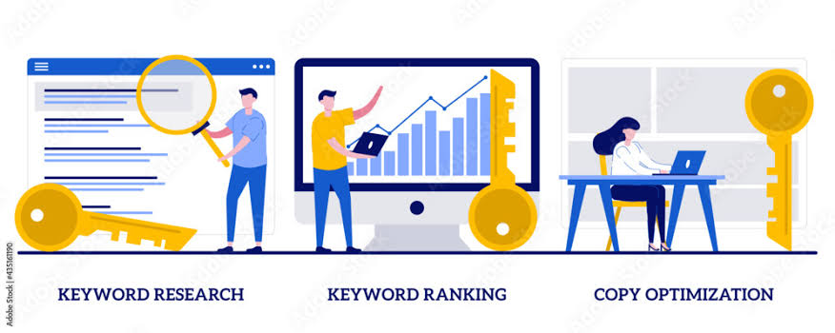

**SEO Keyword Research:**

* **Focus:**
  + Primarily concerned with optimizing website content to rank higher in organic search results on search engines like Google.
  + Emphasis is on understanding search intent and aligning website content with what users are actively searching for.
* **Goals:**
  + Drive organic traffic to a website.
  + Improve website visibility in search engine results pages (SERPs).
  + Attract users who are actively seeking specific information or products.
* **Characteristics:**
  + Heavily reliant on understanding search engine algorithms and ranking factors.
  + Involves analyzing keyword difficulty, search volume, and competitive landscape.
  + Focuses on optimizing on-page elements (e.g., title tags, meta descriptions, content) and off-page factors (e.g., backlinks).
  + Often, the keywords are worked into content in a natural way, so that the content is still easy for a human to read.
* **Example:**
  + Identifying keywords like "organic dairy products," "buy fresh milk online," or "dairy nutrition facts" to optimize product pages or blog content.

**Digital Marketing Keyword Research:**

* **Focus:**
  + Encompasses a broader range of digital marketing activities, including SEO, paid advertising (PPC), social media marketing, and content marketing.
  + Aims to understand audience interests and preferences across various digital channels.
* **Goals:**
  + Drive traffic and engagement across multiple digital platforms.
  + Reach target audiences with relevant marketing messages.
  + Generate leads and conversions.
* **Characteristics:**
  + Involves analyzing keyword trends and user behavior across various digital channels.
  + May include researching keywords for paid advertising campaigns (e.g., Google Ads), social media targeting, or video marketing.
  + Focuses on understanding the context and intent behind keyword usage across different platforms.
  + Keyword research here can also be used to find what words people are using when discussing a product on social media.
* **Example:**
  + Using keywords like "dairy product discounts," "healthy dairy recipes," or "dairy product reviews" for targeted social media ads or email marketing campaigns.

**Key Differences:**

* **Scope:** SEO keyword research is a subset of digital marketing keyword research.
* **Purpose:** SEO focuses on organic search visibility, while digital marketing aims to reach audiences across various digital channels.
* **Application:** SEO keywords are primarily used for website optimization, while digital marketing keywords are used for a wider range of marketing activities.

**On page Optimization**

When applying on-page optimization principles to Hatsun Agro Products Limited's digital marketing, the goal is to enhance the visibility of their online presence for relevant search queries. Here's how to tailor on-page optimization to their specific context:

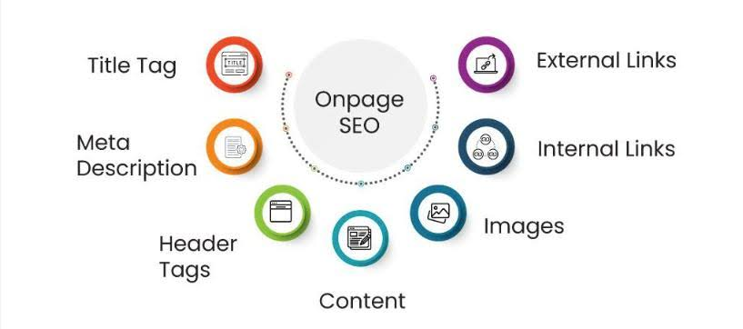

**1. Tailored Keyword Integration:**

* **Product-Specific Keywords:**
  + Prioritize keywords related to their core products: "Arokya milk," "Arun ice cream flavors," "Hatsun curd benefits," "Hatsun ghee online."
  + Integrate these keywords naturally into product descriptions, titles, and header tags.
* **Regional Keywords:**
  + Given Hatsun Agro's strong regional presence in Southern India, incorporate location-based keywords: "[City name] fresh milk," "[Region] dairy products."
  + This is crucial for local SEO, helping regional consumers find their products.
* **Informational Keywords:**
  + Create content that addresses consumer questions: "dairy nutrition information," "recipes with Hatsun curd," "benefits of ghee in cooking."
  + This attracts users seeking information, establishing Hatsun Agro as a trusted resource.

**2. On-Page Element Optimization:**

* **Product Pages:**
  + Optimize product titles and descriptions with relevant keywords.
  + Use high-quality images with descriptive alt text.
  + Include customer reviews and ratings.
* **Blog Content:**
  + Create informative blog posts related to dairy, nutrition, and cooking.
  + Optimize blog posts with relevant keywords and header tags.
  + Use internal linking to connect related content.
* **Local SEO Optimization:**
  + Ensure consistent NAP (Name, Address, Phone number) information across all pages.
  + Optimize location-specific landing pages.
  + Embed Google Maps and local business listings.

**3. Content Strategy:**

* **High-Quality Content:**
  + Focus on creating valuable and engaging content that satisfies user intent.
  + This could include recipes, nutritional information, and stories about their farmer partnerships.
* **Multimedia Content:**
  + Incorporate videos and images to enhance user engagement.
  + Optimize multimedia content with relevant keywords.
* **Mobile Optimization:**
  + Ensure that all pages are optimized for mobile devices. This is very important, as many people access the internet via mobile devices.

**4. Technical On-Page SEO:**

* **Website Speed:**
  + Optimize website loading speed for a better user experience.
* **Mobile-Friendliness:**
  + Ensure the website is fully responsive and mobile-friendly.
* **Schema Markup:**
  + Implement schema markup to provide search engines with structured data about products and recipes.

**Content ideas and marketing strategies**

Here's a comprehensive approach to content ideas and marketing strategies for Hatsun Agro Products Limited in the digital sphere, combining engaging content with effective marketing tactics:



**Content Ideas:**

* **Recipe Content:**
  + "Easy Recipes with Arokya Curd": Short video tutorials or step-by-step blog posts.
  + "Healthy Desserts with Arun Ice Cream": Showcasing creative ways to use their ice cream in desserts.
  + "Traditional Ghee-Based Dishes": Highlighting regional recipes and the benefits of Hatsun ghee.
* **Nutritional Content:**
  + "The Nutritional Benefits of Fresh Milk": Informative articles or infographics.
  + "Understanding Dairy Nutrition for Families": Expert interviews or articles on dietary needs.
  + "Debunking Dairy Myths": Addressing common misconceptions about dairy products.
* **Behind-the-Scenes Content:**
  + "A Day in the Life of a Hatsun Farmer": Showcasing their direct sourcing practices.
  + "The Journey from Farm to Table": Visual content highlighting their production process.
  + "Meet the People Behind Hatsun": Employee spotlights and stories.
* **Interactive Content:**
  + "Dairy Nutrition Quizzes": Engaging quizzes to educate consumers.
  + "Flavor Polls and Contests": Interactive content on social media to boost engagement.
  + "Virtual Farm Tours": Utilizing 360-degree videos or virtual reality.
* **Regional Content:**
  + Content in local languages.
  + Highlighting regionally popular ways to use their products.
  + Working with local influencers.
* **User-Generated Content (UGC):**
  + Encourage customers to share their recipes and experiences with Hatsun products.
  + Run UGC contests and campaigns.
  + Feature customer testimonials and reviews.

**Marketing Strategies:**

* **Social Media Marketing:**
  + **Platform-Specific Content:** Tailor content to each platform (e.g., visually appealing content for Instagram, short videos for TikTok).
  + **Influencer Marketing:** Partner with food bloggers, nutritionists, and lifestyle influencers.
  + **Social Media Advertising:** Run targeted ads to reach specific audience segments.
  + **Community Building:** Engage with followers, respond to comments, and build a loyal community.
* **Search Engine Optimization (SEO):**
  + Optimize website and content for relevant keywords.
  + Focus on local SEO to reach regional consumers.
  + Build high-quality backlinks.
* **Content Marketing:**
  + Create a blog with valuable and informative content.
  + Develop video content for YouTube and social media.
  + Utilize email marketing to nurture leads and promote products.
* **Paid Advertising (PPC):**
  + Run targeted Google Ads campaigns to reach users searching for dairy products.
  + Utilize retargeting to reach users who have previously interacted with the brand.
  + Utilize shopping ads for direct sales.
* **E-commerce and Online Sales:**
  + Enhance the online shopping experience on their website.
  + Partner with online grocery delivery services.
  + Offer online promotions and discounts.
* **Email Marketing:**
  + Create email lists segmented by customer type.
  + Send out newsletters with recipes, product information, and promotions.
  + Use email automation for order confirmations and abandoned cart recovery.
* **Loyalty Programs:**
  + Create a digital loyalty program to reward repeat customers.
  + Offer exclusive discounts and promotions to loyalty members.
* **Mobile Marketing:**
  + Optimize all digital content for mobile devices.
  + Explore the use of mobile apps and SMS marketing.
* **Data Analytics:**
  + Use analytics tools to track campaign performance and identify areas for improvement.
  + Analyze customer data to personalize marketing messages.

**Content Idea generation & strategy**

Let's dive deeper into content idea generation and strategy for Hatsun Agro Products Limited, focusing on creating a sustainable and engaging digital presence.

**Content Idea Generation:**

1. **Leverage Product Versatility:**
   * **"10 Ways to Use Curd Beyond Raita":** Explore diverse applications of curd in cooking.
   * **"Ice Cream Hacks for Summer":** Creative ways to use Arun Ice Cream in desserts and drinks.
   * **"Ghee as a Superfood Ingredient":** Highlight the health benefits and culinary uses of Hatsun ghee.
2. **Focus on Health and Wellness:**
   * **"Dairy for Strong Bones: A Nutritional Guide":** Educational content about the calcium and vitamin D content of dairy.
   * **"Probiotics in Curd: Benefits for Gut Health":** Informative content about the health benefits of probiotics in Hatsun curd.
   * **"Lactose Intolerance: Understanding Dairy Alternatives":** Address consumer concerns and provide solutions.
3. **Highlight Farmer Partnerships:**
   * **"Meet Our Farmers: Stories of Sustainable Dairy Farming":** Humanize the brand by showcasing the farmers' contributions.
   * **"The Journey of Milk: From Farm to Your Table":** Visual storytelling about the production process.
   * **"Fair Practices: How Hatsun Supports Local Farmers":** Emphasize ethical sourcing and community support.
4. **Create Regional Content:**
   * **"Regional Recipes with Local Ingredients and Hatsun Products":** Create content in regional languages.
   * **"Festive Recipes with Hatsun Products":** Tailor content to regional festivals and celebrations.
   * **"Local Influencer Collaborations":** Partner with regional influencers to create authentic content.
5. **Interactive and Engaging Content:**
   * **"Dairy Trivia and Quizzes":** Test consumer knowledge and engage them in a fun way.
   * **"Recipe Challenges and Contests":** Encourage user-generated content and participation.
   * **"Live Q&A Sessions with Nutritionists or Chefs":** Provide expert advice and answer consumer questions.
6. **Visual Storytelling:**
   * **"Short Recipe Videos":** Create visually appealing and easy-to-follow recipe videos.
   * **"Product Photography and Styling":** Showcase Hatsun products in an attractive and appetizing way.
   * **"Behind-the-Scenes Videos":** Provide insights into the production process and the people behind the brand.

**Content Strategy:**

1. **Content Calendar and Planning:**
   * Create a content calendar to ensure consistent posting and a mix of content types.
   * Plan content around seasonal events, product launches, and promotional campaigns.
2. **Platform Optimization:**
   * Tailor content to each platform:
     + Instagram: Visually appealing photos and short videos.
     + Facebook: Longer videos, articles, and community engagement.
     + YouTube: Recipe videos, behind-the-scenes content, and educational videos.
     + TikTok: short form engaging video content.
   * Use relevant hashtags and keywords.
3. **SEO Integration:**
   * Optimize all content for relevant keywords to improve search engine visibility.
   * Focus on local SEO to reach regional consumers.
   * Create long form blog content to capture informational searches.
4. **Community Building:**
   * Encourage user-generated content and engagement.
   * Respond to comments and messages promptly.
   * Create online communities and forums for Hatsun customers.
5. **Data-Driven Optimization:**
   * Use analytics tools to track content performance and identify what resonates with the audience.
   * Adjust content strategy based on data insights.
   * A/B test content.
6. **Consistent Branding:**
   * Maintain a consistent brand voice and visual identity across all digital platforms.
   * Reinforce key brand messages and values.
7. **Paid and Organic Integration:**
   * Use paid advertising to amplify organic content and reach a wider audience.
   * Use retargeting to reach users who have interacted with the brand's website or social media.

**Marketing Strategies**

Developing effective digital marketing strategies for Hatsun Agro Products Limited requires a multi-faceted approach that leverages various online channels to reach target audiences and drive business growth. Here's a comprehensive breakdown:

**1. Building a Strong Online Presence:**

* **Website Optimization:**
  + Ensure a user-friendly, mobile-responsive website.
  + Optimize product pages with high-quality images, detailed descriptions, and customer reviews.
  + Implement an e-commerce platform for direct online sales.
  + Improve website loading speed for a better user experience.
* **Local SEO:**
  + Optimize Google My Business listings for all locations.
  + Ensure consistent NAP (Name, Address, Phone number) information across all online directories.
  + Generate local citations and reviews.
  + Create location-specific landing pages.
* **Social Media Management:**
  + Maintain active profiles on relevant platforms (Facebook, Instagram, YouTube, etc.).
  + Develop a consistent brand voice and visual identity.
  + Engage with followers, respond to comments, and build a community.

**2. Content Marketing and Engagement:**

* **Content Creation:**
  + Develop high-quality content that educates, entertains, and inspires the target audience.
  + Create recipe videos, nutritional articles, and behind-the-scenes content.
  + Utilize user-generated content (UGC) to build trust and authenticity.
* **Influencer Marketing:**
  + Partner with food bloggers, nutritionists, and lifestyle influencers.
  + Collaborate on sponsored content, product reviews, and recipe creations.
  + Focus on influencers with a strong regional presence.
* **Video Marketing:**
  + Create engaging video content for YouTube and social media.
  + Produce recipe tutorials, product demonstrations, and customer testimonials.
  + Utilize live streaming for Q&A sessions and product launches.

**3. Digital Advertising and Promotion:**

* **Search Engine Marketing (SEM):**
  + Run targeted Google Ads campaigns to reach users searching for dairy products.
  + Utilize keyword research to optimize ad targeting.
  + Implement retargeting to reach users who have previously visited the website.
* **Social Media Advertising:**
  + Run targeted ads on Facebook, Instagram, and other relevant platforms.
  + Utilize demographic and interest-based targeting.
  + Run promotional campaigns and contests.
* **Email Marketing:**
  + Build an email list and send out newsletters with recipes, product information, and promotions.
  + Utilize email automation for order confirmations and abandoned cart recovery.
  + Create segmented email lists, to target specific customer demographics.
* **Online Promotions and Discounts:**
  + Offer online discounts and promotions to incentivize purchases.
  + Run seasonal campaigns and special offers.
  + Implement a digital loyalty program.

**4. Data Analysis and Optimization:**

* **Website Analytics:**
  + Track website traffic, user behavior, and conversion rates.
  + Utilize Google Analytics to gain insights into website performance.
* **Social Media Analytics:**
  + Monitor social media engagement and reach.
  + Analyze social media data to optimize content and campaigns.
* **Campaign Tracking:**
  + Track the performance of all digital marketing campaigns.
  + Utilize UTM parameters to track traffic sources.
  + A/B test different marketing strategies.
* **Customer Relationship Management (CRM):**
  + Implement CRM strategies to track customer interactions.
  + Use customer data to personalize marketing messages.

**Key Considerations:**

* **Regional Focus:** Tailor marketing efforts to specific regions and languages.
* **Mobile-First Approach:** Optimize all digital content for mobile devices.
* **Data-Driven Decision Making:** Utilize analytics to track performance and optimize campaigns.
* **Brand Consistency:** Maintain a consistent brand message and visual identity across all channels.
* **E-commerce integration:** Enhance online shopping experiences.

**Content creation and curation**

Creating and curating compelling content is crucial for Hatsun Agro Products Limited to engage its audience and build a strong online presence. Here's a breakdown of content creation and curation strategies tailored to their brand:



**Content Creation:**

* **Original Content Pillars:**
  + **Recipe-Focused Content:**
    - High-quality recipe videos showcasing the versatility of Hatsun products.
    - Step-by-step recipe blog posts with vibrant photography.
    - Regional recipes highlighting local culinary traditions and Hatsun products.
  + **Nutritional and Health Content:**
    - Informative articles and infographics on the health benefits of dairy.
    - Expert interviews with nutritionists and dietitians.
    - Content addressing common dairy-related questions and concerns.
  + **Behind-the-Scenes and Farmer Stories:**
    - Videos and photo essays showcasing the company's direct farmer sourcing practices.
    - Stories highlighting the daily lives and contributions of Hatsun's farmers.
    - Content that emphasizes the company's commitment to quality and ethical practices.
  + **Product-Specific Content:**
    - Detailed product descriptions and usage guides.
    - Creative content showcasing the different flavors and varieties of Arun Ice Cream.
    - Content highlighting the unique qualities of Hatsun ghee and paneer.
* **Content Formats:**
  + **Videos:** Recipe tutorials, behind-the-scenes footage, customer testimonials.
  + **Blog Posts:** Informative articles, recipe guides, product reviews.
  + **Infographics:** Visual representations of nutritional information and product benefits.
  + **Social Media Posts:** Engaging visuals, short videos, interactive polls and quizzes.
  + **Live Streams:** Q&A sessions, cooking demonstrations, product launches.
  + **Podcasts:** Interviews with experts, discussions on dairy and nutrition.

**Content Curation:**

* **Sharing Relevant Industry Content:**
  + Curate articles and studies on dairy nutrition and health.
  + Share news and updates from the dairy industry.
  + Highlight relevant content from reputable sources.
* **User-Generated Content (UGC) Curation:**
  + Encourage customers to share their recipes and experiences with Hatsun products.
  + Feature UGC on social media and the company's website.
  + Run UGC contests and campaigns to generate more content.
* **Influencer Content Curation:**
  + Share content created by food bloggers and influencers who use Hatsun products.
  + Repurpose influencer content for social media and other channels.
* **Regional Content Curation:**
  + Share regional recipes, and food related news.
  + Highlight local food events and festivals.
* **Content Curation Tools:**
  + Utilize social media monitoring tools to identify relevant content.
  + Use RSS feeds and content aggregators to discover industry news and articles.
  + Leverage social listening tools to identify trending topics and conversations.

**Content Strategy:**

* **Content Calendar:** Develop a content calendar to ensure consistent posting and a mix of content types.
* **Platform-Specific Content:** Tailor content to each platform's unique characteristics and audience.
* **SEO Optimization:** Optimize all content for relevant keywords to improve search engine visibility.
* **Community Engagement:** Encourage interaction and engagement with content through comments, shares, and likes.
* **Data Analysis:** Track content performance and use data insights to optimize content strategy.
* **Brand Consistency:** Maintain a consistent brand voice and visual identity across all content.
* **Accessibility:** Ensure content is accessible to all users, including those with disabilities.
* **Localization:** Translate and adapt content for regional audiences.

**Post creation**

Creating engaging and effective posts for Hatsun Agro Products Limited requires a strategic approach that considers the brand's values, target audience, and digital platform. Here's a breakdown of post creation strategies:



**1. Platform-Specific Content:**

* **Instagram:**
  + Visually appealing photos and short videos showcasing products, recipes, and behind-the-scenes glimpses.
  + Use high-quality imagery and consistent branding.
  + Utilize Instagram Stories and Reels for interactive content, polls, and quick recipe demos.
  + Engage with followers through comments and direct messages.
  + Use relevant hashtags to increase reach.
* **Facebook:**
  + Share longer videos, articles, and blog posts.
  + Create engaging captions that encourage interaction and discussion.
  + Utilize Facebook Live for Q&A sessions, cooking demonstrations, and product launches.
  + Run Facebook ads to reach specific target audiences.
  + Create facebook groups for regional areas.
* **YouTube:**
  + Produce high-quality recipe videos, product demonstrations, and behind-the-scenes content.
  + Optimize video titles, descriptions, and tags for search.
  + Create playlists to organize content.
  + Engage with viewers through comments and community posts.
  + Collaborate with food related youtube channels.
* **TikTok:**
  + Create short, engaging videos that highlight product features, recipes, and behind-the-scenes moments.
  + Utilize trending sounds and challenges to increase visibility.
  + Use humor and creativity to capture attention.
  + Use hashtags that are currently trending.
* **LinkedIn:**
  + Share company news, industry insights, and farmer stories.
  + Connect with industry professionals and potential partners.
  + Highlight the company's commitment to quality and sustainability.

**2. Content Themes and Ideas:**

* **Recipe Posts:**
  + Showcase creative ways to use Hatsun products in everyday cooking.
  + Share regional recipes and festive dishes.
  + Create recipe videos and step-by-step photo guides.
* **Nutritional Information:**
  + Share informative posts about the health benefits of dairy.
  + Address common dairy-related questions and concerns.
  + Provide tips for incorporating dairy into a healthy diet.
* **Farmer Stories:**
  + Highlight the company's direct farmer sourcing practices.
  + Share stories about the daily lives and contributions of Hatsun's farmers.
  + Showcase the company's commitment to fair practices and sustainability.
* **Product Spotlights:**
  + Feature individual products and highlight their unique qualities.
  + Share product usage tips and creative serving suggestions.
  + Showcase customer reviews and testimonials.
* **Behind-the-Scenes Content:**
  + Provide glimpses into the production process and the people behind the brand.
  + Share photos and videos of the company's facilities and operations.
  + Showcase the company's commitment to quality and hygiene.
* **Interactive Posts:**
  + Run polls, quizzes, and contests to engage followers.
  + Ask questions and encourage comments.
  + Utilize live Q&A sessions and cooking demonstrations.
* **Regional and Festive Posts:**
  + Create posts that are specific to regional festivals.
  + Create posts in regional languages.
  + Highlight regional ways that the products are used.

**3. Post Creation Best Practices:**

* **Use High-Quality Visuals:**
  + Invest in professional photography and videography.
  + Use consistent branding and visual style.
* **Write Engaging Captions:**
  + Keep captions concise and easy to read.
  + Use a friendly and conversational tone.
  + Include a call to action (e.g., "Try this recipe," "Visit our website").
* **Use Relevant Hashtags:**
  + Research and use relevant hashtags to increase reach.
  + Create branded hashtags to promote campaigns and products.
* **Engage with Followers:**
  + Respond to comments and messages promptly.
  + Encourage interaction and discussion.
  + Build a community of loyal followers.
* **Track Performance:**
  + Use analytics tools to track post performance.
  + Analyze data to identify what resonates with the audience.
  + Adjust content strategy based on data insights.
* **Maintain Brand Consistency:**
  + Ensure that all posts adhere to the brands established guidelines.
* **Accessibility:**
  + Ensure that content is accessible to all users, including those with disabilities.

**Designs/video editing**

Based on the search results, Hatsun Agro Products Limited utilizes design and video editing for various purposes, primarily related to:



* **Marketing and Advertising:**
  + They produce television commercials (TVCs) for their various brands, such as "Arun Ice Creams" and "Hatsun Curd." This involves professional video editing and design to create engaging advertisements.
  + These efforts are done through advertising agencies and production houses.
* **Corporate Communications:**
  + Hatsun Agro Products Limited also creates videos for corporate communications, including showcasing their manufacturing facilities and processes. For example videos showing their automated dairy plants.
  + They have a section on their website dedicated to videos. This would include corporate information.
* **Investor Relations:**
  + They provide video content related to investor information.

**Social media Ad campaigns**

Based on the search results, Hatsun Agro Products Limited's social media ad campaign strategies present a mixed picture:



* **Presence and Activity:**
  + They do utilize social media platforms like Facebook, Instagram, and potentially others to connect with consumers.
  + They share updates on new products, promotions, and events.
  + They emphasize visual content, using images and videos to showcase their products.
* **Areas for Improvement:**
  + Some analyses indicate that their social media engagement could be stronger.
  + There are observations that compared to competitors, their social media presence could be more robust.
  + One source pointed out that their linked in presence is very poor.
* **Key Focus:**
  + Their campaigns aim to increase brand awareness and engage with their target audience.
  + They are working to protect their brand from fraudulent social media activity.

**Email ad campaigns**

Unfortunately, finding detailed, specific information on Hatsun Agro Products Limited's precise email advertising campaign strategies is difficult. However, I can provide some insights based on the available information:



* **Corporate Communications:**
  + Hatsun Agro Products Limited does utilize email for corporate communications. This is evident in the contact information provided for investor relations and grievance redressal on their official website.
  + Therefore, they use email to communicate with investors, stakeholders, and for handling customer inquiries.
* **Fraud Prevention:**
  + Hatsun Agro Products Limited emphasizes caution regarding fraudulent online activity. This suggests they may use email to warn customers and partners about potential scams.
  + They actively provide contact information on their official website, urging people to use those official channels, instead of responding to possibly fraudulent emails. This shows they are aware of the risks, and are taking steps to mitigate them.
* **General Communication:**
  + It's reasonable to assume that, like many large companies, Hatsun Agro Products Limited uses email for general communication with customers, distributors, and other business partners. This could include:
    - Distributing promotional materials.
    - Sharing product updates.
    - Providing customer support.